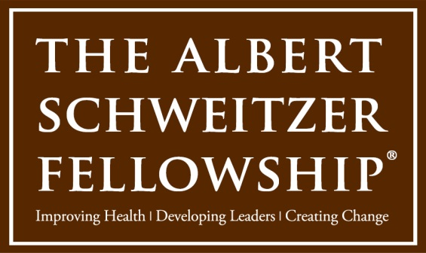

Chicago Area Schweitzer Fellows Program
2020 SEED GRANT Application

Schweitzer Fellows for Life are invited to submit proposals for seed grants of up to $3,000 to create, sustain, or build upon a year-long project to help improve the health and well-being of an underserved Chicago community.
The project should be direct service oriented and should involve an existing community-based organization. The Fellow for Life who is submitting the proposal must be directly and principally involved with the design, implementation, and reporting for the project.

Applications accepted through May 8, 2020 at 5pm CDT by email attachment to mbauer@hmprg.org or snail-mailed to:

Maya Bauer
Schweitzer Fellowship, HMPRG
29 E. Madison Street, Suite 602
Chicago, IL 60602

- Grants of up to $3,000 per proposal are available.
- Proposed projects must have a 1 year timeframe, and concretely describe goals, objectives, activities, measurable objectives and evaluation methods to be considered.
- Proposals that involve interdisciplinary collaboration of health professionals, and especially 2 or more Fellows for Life are encouraged.
- Chicago FFLs who currently reside in the Chicago area are eligible to apply. Schweitzer FFLs from other US-based programs or from Lambaréné who now live in the Chicago area are also eligible to apply.

Chicago Area Schweitzer Fellows Program
2020-21 SEED GRANT Application

TO APPLY:

1. Write a 1-2 page summary of your intended project, which includes the following:
- Population served, and health need(s) to be addressed
- Intended impact
- Goals, objectives and evaluation metrics
- Collaborators and/or other supporters
- Plan for sustainability
- Project title, if applicable

2. Include a project budget that indicates how the grant will be utilized. Please also list other potential income sources for the project, if applicable.
3. Title document with your first and last name of applicant as well as ‘Schweitzer Seed Grant.’ Include this form.

First Name: | Last Name:
Address: | City: | State: | Zip:
Phone: | Email Address:
What year were you a Schweitzer Fellow (please indicate which program if other than Chicago)?

What is your current occupation, title, and/or other relevant affiliations?

Short description of your project:
Example: Bryon Brown, 2009-10 Fellow for Life, will work with African American residents of the Back of the Yards Neighborhood to develop intergenerational trauma-informed asset-based classes and workshops for their neighbors.

Will your Seed Grant Project continue an existing Schweitzer Fellowship Project (not a requirement)?
If ‘Yes’ please provide further information:

Email your summary and budget to Maya Bauer (mbauer@hmprg.org)
no later than May 8, 2020 for consideration.

